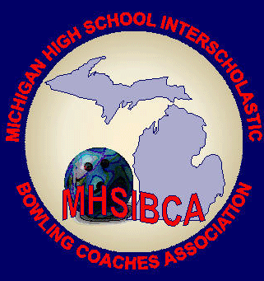
Michigan High School Bowling Coaches Association
Team Academic All State Application
Committee: Scott Spahr, Suzy Thayer

A current member of the MHSIBCA must be listed on this form.
Reminder: Coaches or other school representative submitting applications must be a member of the MHSBCA by Feb. 10, 2024.

General Information
Only athletes whose coach or athletic directors are current members of the MHSIBCA are eligible to be nominated for this award.
- Athletes who have been suspended for an MHSAA rule violation are ineligible. Foreign Exchange students are ineligible to be considered toward the team criteria.
- Coaches must submit a copy of their Regional Roster listing each bowler along with a completed application. The coach is required to fill out the application and the committee must be able to reach him/her if clarification is required.
- Any information that is NOT VERIFIED by a league sheet and a transcript will not be considered. Transcripts must be submitted for each athlete.
- Applications must be returned to the All-State Team/Academic Committee prior to the deadline. Late applications will not be considered. Deadline is February 24, 2024.
Team Criteria
Use six members of the same team who competed in the MHSAA Regional Tournament.
- Minimum combined average of 3.65 on a 4.0 scale (GPA’s will be automatically calculated).
- Players with all A’s receive bonus points according to their grade level, (ex: 10th graders receive 4.05, 11th graders receive 4.10, and 12th graders 4.15).
- The six individual transcripts (as of 2/1/2024) must be mailed and confirmed as received to verify grade point averages.
- Teams that achieve Academic All State status will be awarded a certificate of achievement. Athletic Director’s may complete a fillable form on the MHSIBCA.com website.

MHSIBCA Team Academic All State Application
Incomplete forms will not be considered. PLEASE PRINT
School: _________________________________________________________Division: _____ Male/Female (mixed will use male)
School Address: __________________________________________________City: ______________Zip: _______
Athletic Director: __________________________________________________Phone: _______________Email: ______________
MHSIBCA Member Coaches Name: __________________________________________Phone: __________
Application Deadline is February 24, 2024
Team Roster...Must be six players who competed at MHSAA Regional Tournament
- __________________________________________________________Grade: _________GPA: ____
- __________________________________________________________Grade: _________GPA: ____
- __________________________________________________________Grade: _________GPA: ____
- __________________________________________________________Grade: _________GPA: ____
- __________________________________________________________Grade: _________GPA: ____
- __________________________________________________________Grade: _________GPA: ____

Division I & II Division III Division IV
MHSIBCA Academic All State MHSIBCA Academic All State MHSIBCA Academic All State
Scott Spahr Suzy Thayer
101 Mechanic St. 5262 Thames Ct.
Sturgis, MI 49091 Jackson, MI 49201
269-625-8943 517-740-4339
aic11367@yahoo.com sthayer1@hotmail.com

