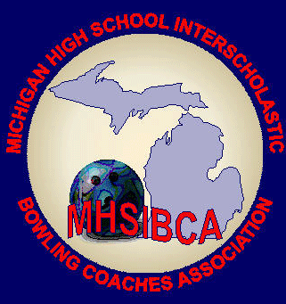
Michigan High School Bowling Coaches Association
Hall of Fame Nomination Form

Deadline: February 24, 2024
Mail to: MHSIBCA Hall of Fame
C/O Scott Spahr
101 Mechanic St.
Sturgis, MI 49091-1725
aic11367@yahoo.com 269-625-8943

Nominee: ________________________________________School: _______________________________
Open to individuals that have made the sport what it is today.
(Bowling center owners, proprietors or managers, news media, volunteers, and coaches)

For a coach to be nominated, they must have been a bowling coach for a minimum of 16 years

Number of years coaching high school bowling ______ Overall dual meet record_______
Number of years as an MHSIBCA member _______ League/Conference Championships_______
State Tournament appearances________ Regional Championships Team_________
State Championships Team___________ Regional Championships Singles_________
State Championships Singles_________
Coaching honors or recognitions______________________________________________________________________

Why are you nominating this individual and what have they done to deserve this nomination?
___________________________________________________________________________________________________________________________________________________________________________________________________________________________________________________________________________________________________________________________________________________________________________________________________________________________________________________________________________________________________________________________________________________________________________________________________________________________________________________________________________________________________________________________________________________________________________________________________________________________________________________________________________________________________________________________________________________________________________________________________________________________________________________________________________________________________________You may also submit a typed answer

Name of person submitting the nomination and contact information (please print)
Name: ________________________________________________Phone: ________________________________
Address: ____________________________________________City: _______________________Zip: __________
Email: _________________________________________________________

