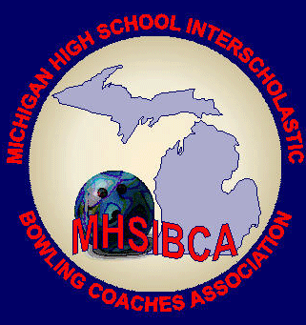
Michigan High School Bowling Coaches Association
Coach of the Year Nomination Form

Deadline: February 24, 2024
Mail to: MHSIBCA Hall of Fame
C/O Scott Spahr
101 Mechanic St.
Sturgis, MI 49091-1725
aic11367@yahoo.com 269-625-8943

Nominated Coaches Name: ________________________________________________________________

School Affiliation: ______________________________________________

Division: _________Boys: _____Girls: _____

Season Conference Record: __________ Regional Results: _____________

State Finals Results: __________________________________________________________________

- Why do you feel this coach should be nominated? _________________________________________
_________________________________________________________________________________
- What has the coach done to improve high school bowling? __________________________________
__________________________________________________________________________________
- What else has this coach done beyond the actual coaching of the team?_____________________________________________________________________________
- Does he/she belong to the coaches association? _______________________________________________
- Does he/she attend association meetings or volunteer for other functions outside of coaching his/her teams?____________________________________________________________________________
- Has this coach made an impact beyond coaching his/her teams?______________________________
Other:__________________________________________________________________________________
_______________________________________________________________________________________
_______________________________________________________________________________________
_______________________________________________________________________________________

Name of person submitting the nomination: ____________________________________________________
Phone: _____________________________
Email: ______________________________

