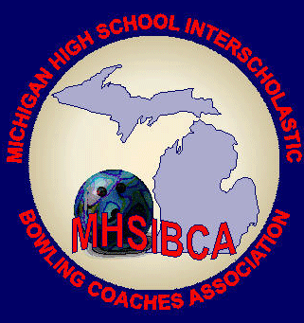
Michigan High School Bowling Coaches Association
Individual Academic All State Application
Committee: Scott Spahr, Suzy Thayer
A current member of the MHSIBCA must be listed on this form. Please submit any Senior Student Athlete who has achieved a GPA of 3.65 or higher.
Reminder: Coaches or other school representative submitting applications must be a member of the MHSBCA by Feb. 10, 2024.
General InformationOnly athletes whose coach or athletic directors are current members of the MHSIBCA are eligible for this award.
- Athletes who have been suspended for an MHSAA rule violation are ineligible.
- Coaches must submit a FINAL LEAGUE sheet listing each bowler nominated along with a completed application. The coach is required to fill out the application and the committee must be able to reach him/her if clarification is required.
- Any information that is NOT VERIFIED by a league sheet and a transcript will not be considered.
- Applications must be returned to the All-State Team/Academic Committee prior to the deadline. Late applications will not be considered.
MHSIBCA Academic All State Application
Incomplete forms will not be considered. PLEASE PRINT

Athlete Name: __________________________________________Male/Female____ Division:____
GPA: _________ Number of Games Bowled: ____________
School: _______________________________________Conference: _____________________________
Athlete Address: ___________________________________City: _______________________Zip: _______
Coach Name: _________________________________________ Phone: ___________________________
(Designated MHSIBCA Member)
Athletic Director: _______________________________________ Phone: __________________________

Athletic Director Email: ____________________________________________________________________
School Address: ___________________________________City: ______________________Zip: _________
Mailing Instruction for Coaches—Deadline February 24, 2024
Include Transcript and Proof of Games Bowled

Division I & II Division III Division IV
MHSIBCA Academic All State MHSIBCA Academic All State MHSIBCA Academic All State
Scott Spahr Suzy Thayer
101 Mechanic St. 5262 Thames Ct.
Sturgis, MI 49091 Jackson, MI 49201
269-625-8943 517-740-4339
aic11367@yahoo.com sthayer1@hotmail.com

