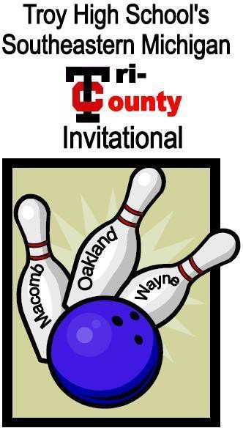
Official
2024 Form
First
50 Teams

Team Tournament (All Baker Format)
Saturday, January 27th, 2024 @930 a.m
(Doors open at 8:15a.m.)
2666 Metropolitan Parkway, Sterling Heights
Entry Fee: $100.00 per team

Make Checks Payable to: TROY HIGH SCHOOL
Mail to: Troy High Athletics Dept.
4777 Northfield Parkway
Troy, MI 48098

Email Entry Form to: Coach Margo at Nicholas.a.margo@gmail.com
Phone:

Entry Deadline: Tuesday, January 16, 2024

ADMISSION FEE: $5.00

TROY HIGH SCHOOL’S SOUTHEASTERN MICHIGAN TRI-COUNTY INVITATIONAL
Championship Format
Doors Open 8:15 a.m.
- There will be one varsity division for boys and one varsity division for girls.
- This event will be an all Baker Format. All games will be bowled Baker Style. (First bowler will bowl frames 1 & 6; second bowler will bowl frames 2 & 7; and so on). Line ups can be changed at the beginning of each Baker game. Mid-game and mid-frame substitutions will be allowed. Bowler subbed in must complete that game.
- Lane assignments will be pre-assigned by the tournament committee prior to check-in.
- At 9:30 am, a 15 minute practice session will begin. There will be a coaches meeting prior to warm-ups at 9:00 am.
- Qualifying will consist of 12 total games, bowling 4 games on 3 different pairs. For each 4 game set, teams will bowl 2 baker games on one lane and then 2 baker games on the opposite lane.
- The competition will then be cut to the top 16 Boys teams and the top 16 Girls teams after the completion of the 12 game qualifier. In the event of a tie for any place we will use the total pins of the last 4 game Baker set as a
tie-breaker to decide seeding. If that is a tie we will go to the middle 4 game Baker set next and so on.
- There will be approximately a 30 minute meal break after the qualifier.
- After the meal break, there will be a 10 minute practice session.
- The competition will be seeded in matches using the NCAA format. (Top Seed vs. Bottom Seed etc.)
- Next, teams will bowl head-to-head in best of three Baker matches, until the field is down to the final four teams. Matches will be decided by the team who wins two games. There is no roll off for a tied game. That game is declared a tie and move on to the next game. In the event one game is tied, then that match will end up being decided by total pins for the 3 games, followed by a 5 frame roll-off if necessary as the next tie breaker.
- Higher (better) seed will bowl 1st game on odd lane and 2nd game on even lane. Then, they will have lane choice if the match goes to a 3rd game. The winners of the semis will bowl for first and second place, while the losers will bowl for third and fourth place. First place matches will still be best of three games like all of match play. Consolation matches will be 2 games and decided by total pins. In the event of a tie for total pins in consolation match, 3rd place will be awarded to the team that bowled the highest game in the consolation match.
- Trophies/Medals will be given to the top three teams in each division following the event. 4th place team will receive a team trophy.
- Please e-mail us ASAP to have your teams put on the list. Those coaches who verbally asked to be put on the list must also e-mail us to confirm their commitment. Any questions please email Nicholas.a.margo@gmail.com.
- Schools that contact us after the tournament is filled will be put on a waiting list on a first come basis.
- Once the tournament begins no alteration will be allowed to be done to the bowling balls. Rosins or powders can be applied to the bowlers hand only. One lane courtesy should be observed during competition.
- No substance is allowed to be applied to the bottom of the bowler’s shoes during the tournament.

Rules and Regulations
- MHSAA, USBC and MHSIBCA rules and regulations will govern this tournament.
- This event is open to all current high schools which have a Varsity Team in High School Competition.
- Only registered bowlers may bowl. Roster should be 7 bowlers. 5 starters and 2 substitutes.
- ENTRY FEE: is $100.00 per team and must accompany the entry form. No refunds will be issued. Checks returned for insufficient funds will be assessed a $25.00 fee.
- Money and Entry forms must be received by January 16, 2023. If the deadline cannot be met arrangements can be made. If no arrangements are made and money is not received, we will contact schools on the waiting list to fill your spot.
- This is a scratch tournament (no handicap).
- Bowlers should bring their own equipment. All equipment used in the tournament must meet USBC specifications. Maximum of 2 balls per bowler in the bowling area. No bowling ball bags are allowed in the bowling area.
- Bowling Attire: All bowlers should be dressed in team shirts and similar color pants. School shirts must reflect the school name, logo or mascot. No hats or jeans will be allowed.
- Only registered bowlers and coaches are allowed in the immediate bowling area.
- No tobacco products, drinking of alcoholic beverages or unsportsmanlike conduct will be permitted while participating in the event. Outside food or beverages are not allowed to be brought into the center.
- All scores as recorded and verified on score sheet are final. Corrections will only be made on computer entry errors.
- Any disputes during the tournament or exceptions to the above rules and regulations will be resolved by the tournament management and/or the tournament committee.

TROY HIGH SCHOOL’S SOUTHEASTERN MICHIGAN TRI-COUNTY INVITATIONAL

School:
Coach:
Address:
Phone: E-Mail:

Boys Team Roster | Girls Team Roster
1 | 1
2 | 2
3 | 3
4 | 4
5 | 5
ALT | ALT
ALT | ALT

Email Entry Form to
Entry Fee: $100.00 per team
Make checks payable to: TROY HIGH SCHOOL
Athletic Department
4777 Northfield Parkway
Troy, MI 48098

