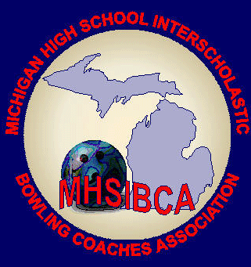

Insert Bowlers Names

MHSIBCA Recognizes

Date

Date

Coach Signature

Athletic Director Signature

**For Excellence in Academics while participating in high school sports**

Team Academic All-State Honors